s

Info | Content
Key words | RaspberryPi, 5’’TFTscreen, calibration
Summary | General Calibration on HDMI 5B TFT Screen

52Pi Technology.,LTD

HDMI 5B TFT Screen

Application
Note
General Calibration on HDMI 5B TFT Screen
Application Note
AN010103 V1.0 Date: 2017/05/18

Reversion History
Version | Date | Reason
V1.0 | 2016/5/18 | Create documentation

Index
1. Introduction 1
2. Principle 2
3. Development Environment 3
4. Calibration 4
● Referenced 6
● 8

Introduction
This HDMI 5B TFT Screen is available for those development board as following chart：
Raspberry Pi A
Raspberry Pi A+
Raspberry Pi B
Raspberry Pi B +
Raspberry Pi 2, Model B, 1GB RAM
Raspberry Pi 3, Model B, 1GB RAM
Raspberry Pi Zero

Principle
According to different people has different habits for using this screen, and different people has different pressure when they are pressing the Touchscreen, so you have to calibrate it before you using it。

Development Environment
Hardware Environment：
Raspberry Pi 3, Model B, 1GB RAM
Pi-HDMI-5B 5’’ Resister Touchscreen
HDMI convertor
Wire cable

Software Environment：
OS Type： Raspbian
OS Version： 2016-03-18-raspbian-jessie

Calibration
You need to modify this configuration file in /boot/config.txt and make sure it contains those two parameters in your pi config.txt as following picture:
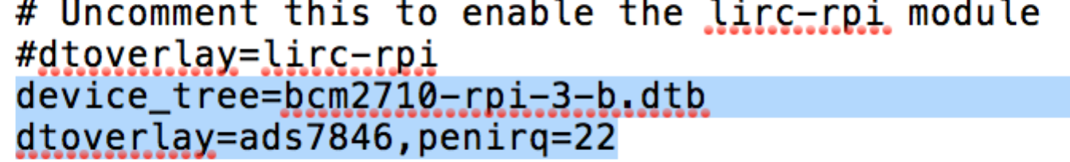
device_tree=bcm2710-rpi-3-b.dtb #This must be fit for your Pi model.
dtoverlay=ads7846,penirq=22
save and reboot your Pi.
Create a configuration file /etc/X11/xorg.conf.d/99-calibration.conf and add those parameters as following:
Section “InputClass”
Identifier “calibration”
MatchProduct “ADS7846 Touchscreen”
Option “Calibration” “0 4095 0 4095”
Option “SwapAxes” “1”
EndSection

Save and reboot your Pi.

Open a terminal after login and type this command to install several packages ：
$sudo apt-get -y install xinput libx11-dev libxext-dev x11proto-input-dev evtest libts-bin

Use this command to start HDMI 5B TFT Screen calibration.
$DISPLAY=:0.0 xinput_calibrator
It will appear a feedback as you press enter and you can find that the Touchscreen start calibrating.
Note： 0，4095，0，4095 those numbers are the baseline for calibrating.
You can press the point in the center of Red Cross to calibrate your Touchscreen when it appears in the four cornor of the screen. You may try several times to calibrate as well.
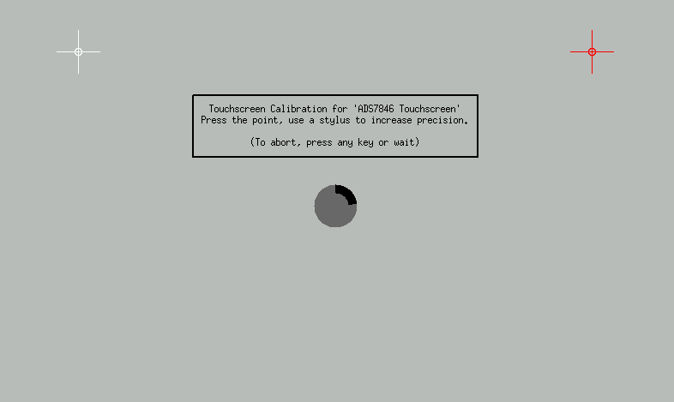
during the calibration, it will count down 60s before your press the point, if you pass the count down, it will exit automatically.
It will exit If calibration is done too.
It will show you some parameters that looks like configuration file in /etc/X11/xorg.conf.d/99-calibration.conf
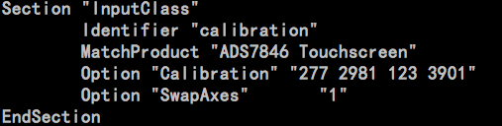you can replace the parameters with this feedback to it in /etc/X11/xorg.conf.d/99-calibration.conf.

Reboot your Pi after calibrating and have fun.

Reference
Download images from：
https://www.raspberrypi.org/downloads

Notice: All referenced brands, product names, service names and trademarks are property of their respective owners.

如因官方系统更新而无法及时更新本文档，请联系我们。
本文档发生更新恕不另行通知。
如果需要索取更多文档请联系产品供应商。

