OS8815BLE OPERATING INSTRUCTION

- User register
Click “Register” ➪ “Register via email”

- Lock Initialization
Open battery compartment cover ➪ remove one battery ➪ lock power cutoff ➪ wait two seconds ➪ insert the battery ➪lock power on ➪ bright touch screen ➪ within 2-5 seconds ➪ press and hold "#" ➪ hear "bit" sound twice ➪ lock initialization success.

- Administrator management（Operated by administrator）
  - Add administrator
Open the TTLOCK ➪ click on the menu bar "Discover" ➪ select "Home Lock" ➪ click the new-presented device name ➪ the page jump to the menu bar of the "ttlock" automatically ➪ administrator added successfully
3.2 Delete administrator
Android: Press the device name ➪ "Delete"
IOS: press and hold the left slide ➪ "Delete"

- Ordinary user management（Operated by administrator）
4.1 Create ordinary user “send & receive key”
Click lock device name ➪ Click "Send key”➪ input admin’s password ➪choose key type “Period key” or “Permanent key” ➪ input receiver’s ttlock account and valid time
Receiver will get notification in ttlock➪ click “user to download” ➪ click “use key”
4.2 Delete & Block ordinary users
Click lock device name ➪ Click "User management" Enter Password ➪ send users through the electronic key ➪ this user to perform the "Delete" “Block" "unfreeze" and other operations.

5.Change device name
Click the lock device name ➪click "About Device" ➪click the "name" ➪ Edit name

6.Set group
Locks can be grouped according to management needs, such as "Purchasing Group", "Business Group", each group needs to be added with a corresponding number of locks
Click lock device name ➪ click "About Device" ➪ Click on "Sort" ➪ create new group ➪ Input new group name

7.Unlock :
Open ttlock APP and bluetooth should be activated, close to the door ,press any button of the keypad, door locks automatically unlock

8. Locking method

8.1 Lock by hand
When lock is in unlock position, press # and the deadbolt will extend out

8.2 Lock automatically
Click the lock device name ➪ click "Password Management" ➪ Click "Admin Password"➪ remember “current password”for example 3532789
Turn off Bluetooth ➪ press * to active the screen ➪ press 21#3532789#30# ➪ four short “didi” means lock setup is complete. Lock will be unlocked automatically in 30 seconds. Locking time can be adjusted by changing the digit between“#”. For example changing the “30” to “25”, the lock will be locked in 25 seconds automatically. The shortest locking time is 25 seconds

8.3 Turn off “locking automatically”
Repeat steps of 7.2, change the digit ”21” to ”20”, after the operation, lock return to “lock by hand”

9. Password Management

9.1 Set the administrator password
Click the lock device name ➪ click "Password Management" ➪ Click "Admin Password" ➪ Click on "Modify Password" ➪ "Change Password" ➪ requires to be set 7-10 digit admin password ➪ "new password"
PS: new password enter into force after Bluetooth unlock the door.

9.2 Setting user password
Click the lock device name ➪ click "Password Management" ➪ click "Reset Keyboard Password " ➪ "Reset" ➪ input admin’s password ➪ input valid password count(1-100) ➪press the "#" ➪ user password reset ➪ click "send keyboard password" ➪ set validity
Administrator setting password expiration "single time" "minute", "hour", "day", "month", "permanent“
➪ Click"get password", the system generates a random 8-digit password and automatically paste to the clipboard, users can whatsapp or text password to the user
10. Check unlock records (Administrator)
Click the lock device name ➪ check the "real-time monitoring" ➪ click "unlock records" to see open records

11. Real time monitor (Administrator)
Click lock device name ➪ click "Real time monitor➪ anyone who unlocks the door, administer will receive notice in smart app

12. Power remind
The following device names have blue battery status alerts, from fully charged to low battery, you can see,
When the battery is low, there will be a voice prompt "lock out of power, please replace the battery."

13.Change lock handing
In the back of the lock, there is toggle on the circuit board
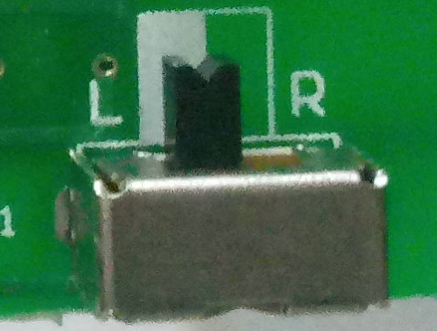

L means the tongue faces left, the door is right opening.

R means the tongue faces right, the door is left opening.

If your door is left opening, toggle the button to R, if your door is right opening, toggle the button to L

Choose the right handing of your door by following picture
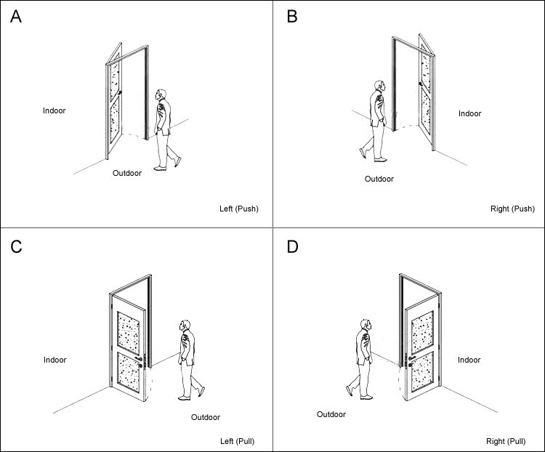
A & C is left handing, turn toggle to “L”
B & D is right handing, turn toggle to “R”

13. Downloading APP by scanning QR Code

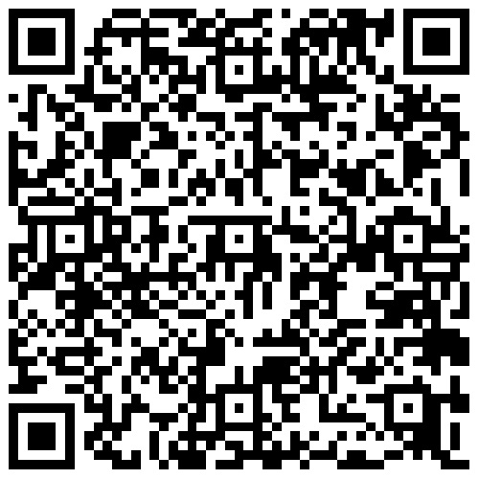  IOS | 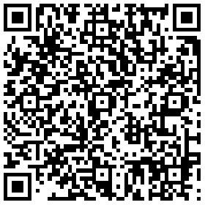  Android
14. IMPORTANT NOTICE
The upper surface of the touch screen is a film protection, you can take it down after installation, it doesn't affect the using if you don't remove it.

note:
There are two ways to unlock: 1, touch the screen lock 2, APP unlock.
Long press # key to close the door lock, first turn off APP

