- Internal logical structure
As shown in the figure below, ADC0809 consists of an 8-channel analog switch, an address latch and decoder, an A/D converter, and a 3-state output latch. The multiplexer can be connected to 8 analog channels, allowing 8 analog time-sharing inputs and sharing A/D converters for conversion. The tri-state output lock is used to latch the A/D converted digital value. When the OE terminal is high, the converted data can be taken from the tri-state output latch.
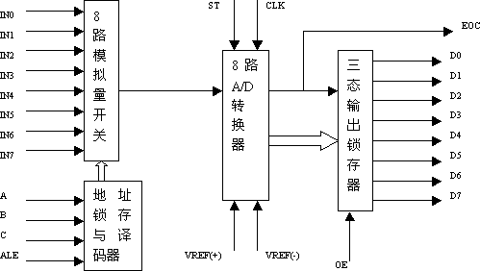

- Pin structure

The functions of each pin of ADC0809 are as follows:
D7-D0: 8-bit digital output pin. IN0-IN7: 8-bit analog input pin.
VCC: +5V operating voltage. GND: Ground. REF(+): Positive reference voltage. REF(-): Negative reference voltage.
START: A/D conversion start signal input. ALE: The address latch allows the signal input.
(The above two signals are used to start A/D conversion.) EOC: Conversion end signal output pin, low level when starting conversion, high level when conversion ends. OE: Output enable control terminal to open the tri-state data output latch. CLK: Clock signal input (typically 500KHz).
A, B, C: Address input line.

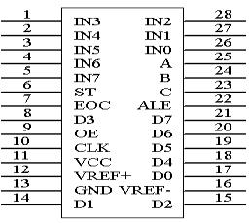
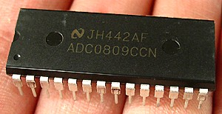

ADC0809 requires analog input: the signal is unipolar, the voltage range is 0-5V. If the signal is too small, it must be amplified. The input analog quantity should remain unchanged during the conversion process. If the analog quantity changes too fast, it needs to be Increase the sample and hold circuit before input.
Address input and control lines: 4 ALEs are address latch enable input lines, active high. When the ALE line is high, the address latch and the decoder latch the address signals of the three address lines A, B, and C. After decoding, the analog input of the selected channel is converted into a converter.
A, B and C are address input lines for strobing an analog input on IN0-IN7. The channel selection table is shown in the table below.
C | B | A | Selected channel
0 | 0 | 0 | IN0
0 | 0 | 1 | IN1
0 | 1 | 0 | IN2
0 | 1 | 1 | IN3
1 | 0 | 0 | IN4
1 | 0 | 1 | IN5
1 | 1 | 0 | IN6
1 | 1 | 1 | IN7

- Digital output and control line: 11

ST is the conversion start signal. When ST is on the edge, all internal registers are cleared; when the next edge is skipped, A/D conversion is started;
ST should be held low during the conversion. EOC is the end of conversion signal. When EOC is high, it indicates the end of the conversion; otherwise, it indicates that A/D conversion is in progress. OE is an output enable signal for controlling the data output from the three output latches to the microcontroller output. OE=1, output converted data; OE=0, the output data line is in a high impedance state. D7-D0 is a digital output line.
CLK is the clock input signal line. Since there is no clock circuit inside the ADC0809, the required clock signal must be provided by the outside world, usually at a frequency of 500KHZ.
VREF(+), VREF(-) are reference voltage inputs.
- ADC0809 Application Description
(1). The ADC0809 has an internal output latch that can be directly connected to the AT89S51 microcontroller.
(2). When initializing, make the ST and OE signals all low.
(3). Send the address of the channel to be converted to the A, B, and C ports.
(4). A positive pulse signal of at least 100 ns wide is given at the ST end.
(5). Whether the conversion is completed, we judge according to the EOC signal.
(6). When EOC goes high, OE is high at this time, and the converted data is output to the microcontroller.
- Experimental tasks
As shown in the figure below, the analog quantity between 0-5V is input from the channel IN3 of ADC0809, and converted into digital quantity by ADC0809, which is displayed in decimal on the digital tube. The VREF of ADC0809 is connected to +5V.
- ADC0809 Application Circuit Schematic
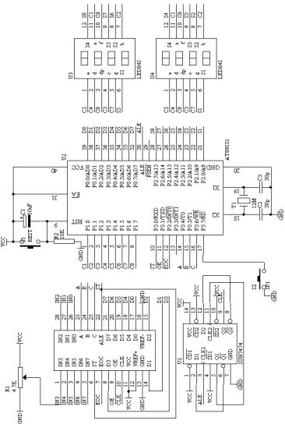
- Programming content
(1). When performing A/D conversion, the EOC flag signal is used to detect whether the A/D conversion is completed. If it is completed, the data is read through the P0 port and displayed on the digital tube after data processing.
(2). The method to start the conversion before performing the A/D conversion:
ABC=110 selects the third channel
ST=0, ST=1, ST=0 produces a positive pulse signal that initiates the conversion.

C language source

#include
unsigned char code dispbitcode[]={0xfe,0xfd,0xfb,0xf7, 0xef,0xdf,0xbf,0x7f};
unsigned char code dispcode[]={0x3f,0x06,0x5b,0x4f,0x66, 0x6d,0x7d,0x07,0x7f,0x6f,0x00};
unsigned char dispbuf[8]={10,10,10,10,10,0,0,0}; unsigned char dispcount;

sbit ST="P3"^0; sbit OE="P3"^1; sbit EOC="P3"^2;
unsigned char channel="0xbc";//IN3 unsigned char getdata;

void main(void)
{ TMOD=0x01;
TH0=(65536-4000)/256; TL0=(65536-4000)%256; TR0=1;
ET0=1;
EA=1;
P3=channel; while(1)
{
ST=0; ST=1; ST=0;
while(EOC==0);
OE=1;
getdata=P0;
OE=0;

