Instruction
PCB positive and negative:
LED1 and LED2 are red, the other is green LED, the attention and negative labeling
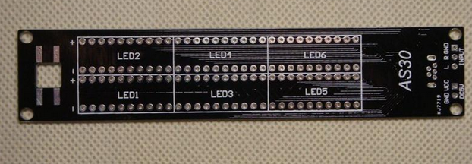

In the following figure R1-R10 is 470 ohm resistor, R11-R30 is 1K resistor, R32, R31 is 10K resistor.

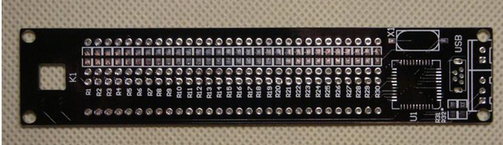

LED has the word one side for positive “+”
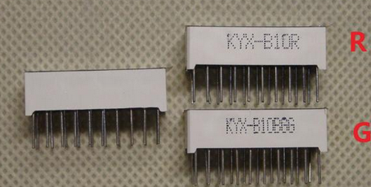
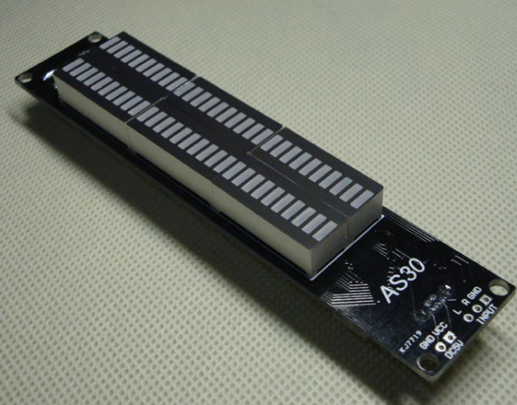
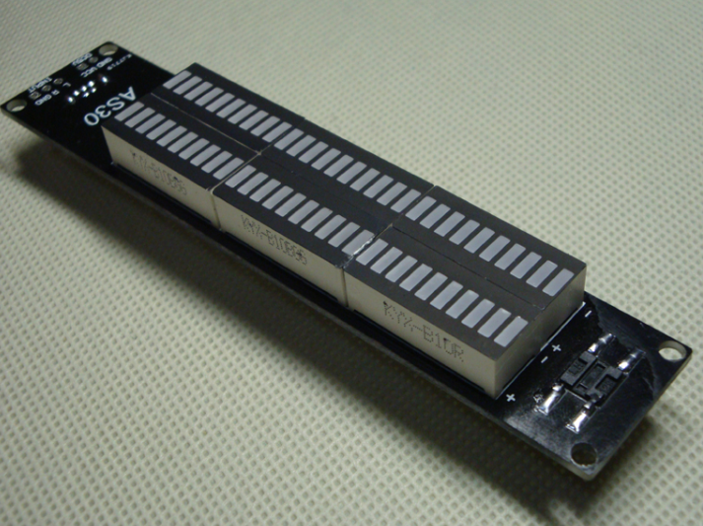

Pay attention to chip direction,The use of white elements for the external input line, if the installation of the shell, please do not install, in particular:
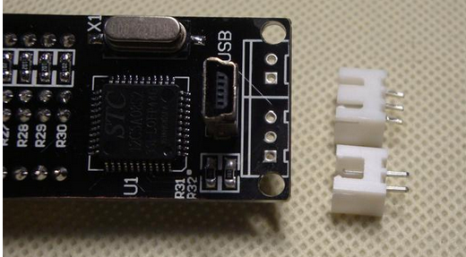
Cut pin:
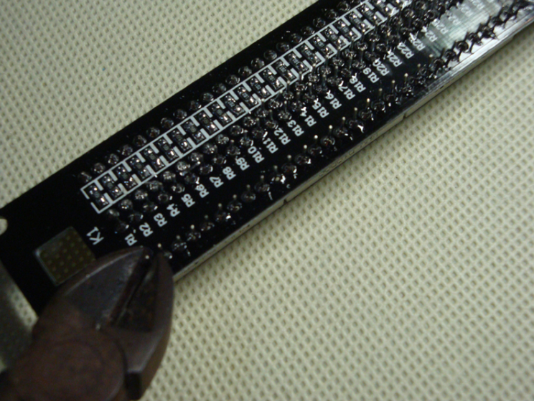
Remove protective film:
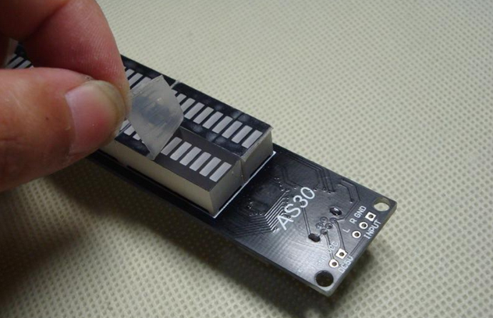
Install black pad matching heightDo not provide a rubber pad, do not need to install the shell does not need to install:
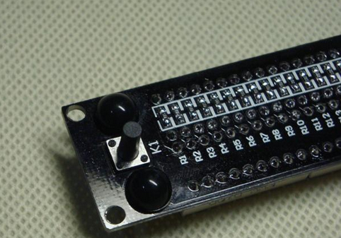

Finish:
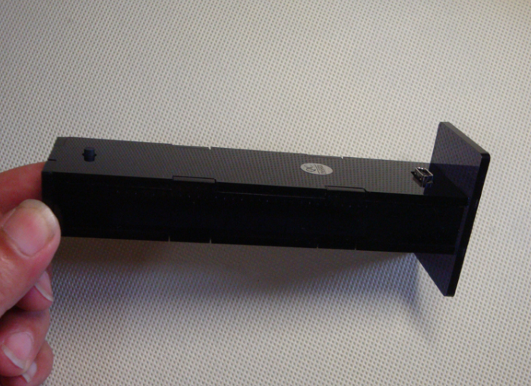

AS30 has 6 kinds of classic display mode, through the key settings, set with memory function.
Mode 1: column mode
Mode 2: column with floating point mode
Mode 3: column with floating point, floating point upward move out mode
Mode 4: single point mode
Mode 5: single point with floating point upward move out mode

Pattern6Single floating mode

Using method:

This product provides a USB, 3.5mm headphone bull combo input line (black and white random) and an audio a second branch device, two USB line end is a power supply end, can use computer USB, 5V mobile phone charger (don't use the cottage charger, high ripple current, the voltage is too high), charging treasure, vehicle mounted USB interface power supply. Headphone head for the signal input, through the branch while the AS30, while the audio equipment. Control by adjusting the output of the computer range

Special note:

1, this package will not provide a paper manual, please read this page description;

2, the package is installed, the LED brightness will be high, this is because the supply of tea black shell will have a certain brightness attenuation, after the installation of the brightness of the soft and beautiful, please use.

3, a housing need fixed with acrylic glue, also can use transparent narrow tape fixed, suite without glue, if need glue please photographed together.

4, this package is relatively simple, if you do not weld chip chip, please pay 2 yuan, will be the chip welding, delivery, I will help you weld a good chip, the rest is very simple.

5, this product provides the data lines are pure copper core quality data line, line length 80 cm, Colour and black and white random hair, hereby.

