Home intelligent monitoring

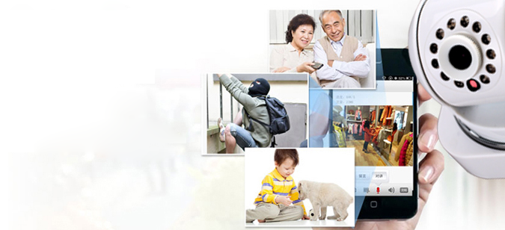

Quick user manual
- Packing list

Item | Pcs
Camera | 1
Power adapter | 1
Quick user manual | 1
Wall base | 1
Screw | Some

2. Operating Environment

Ⅰ)The device using the environment need a wireless router, and real-time access to the Internet;

Ⅱ)Support Explorer :IE 、Safiri、Chrome、Firefox、Opera and so on ；

Ⅲ)Itelligent Terminal：Android （More than Android4.0 version，CPU more than 1GHz），IOS（more than 5.0version ）。

- Install & Configuration

First step: Camera connect power supply ；
Second step: download mobile phone monitor software，as follows:：
①Login web:（www.nvsip.com）to download；
②Login Android market or App Store search “NVSIP” to download
③use mobile phone scanned two-dimension code to download（Android or Apple mobile phone）。

Third step: register and binding email(Android &iOS operation same）
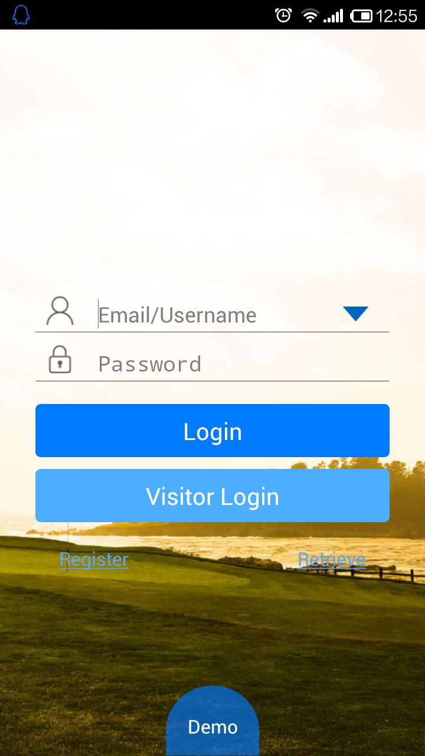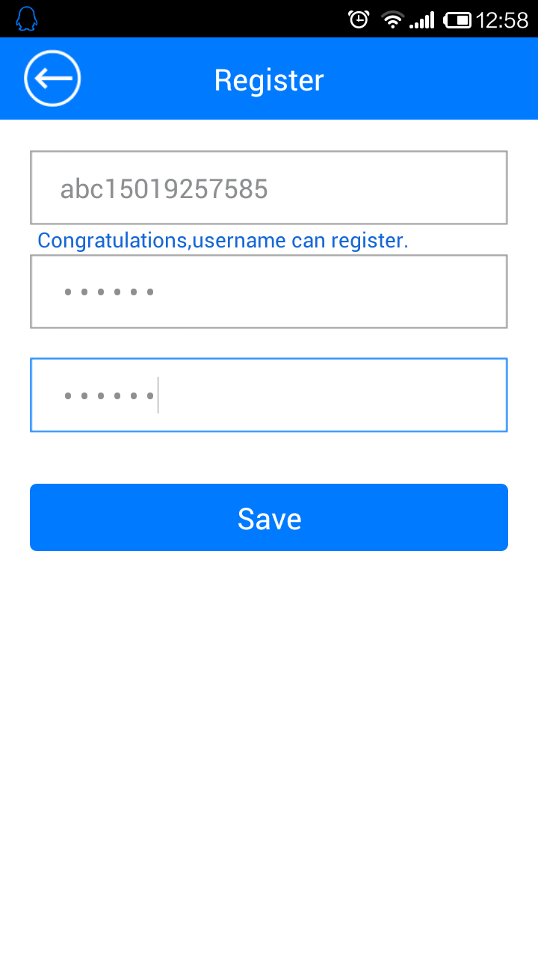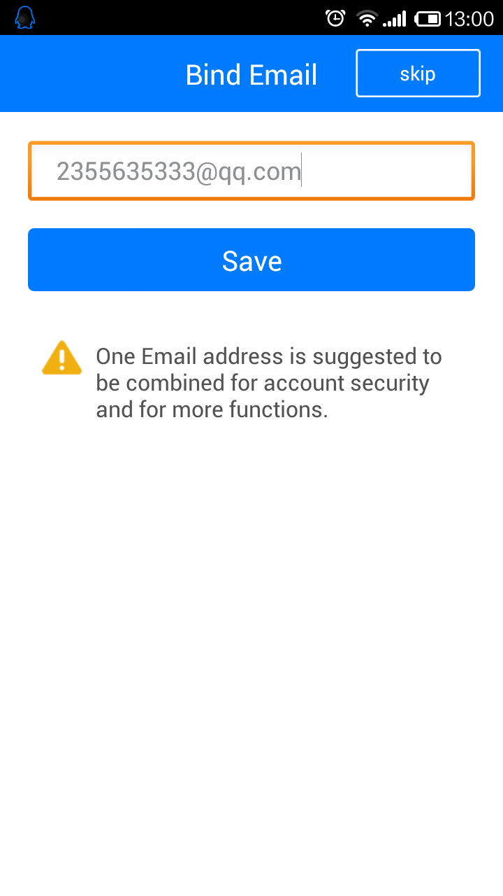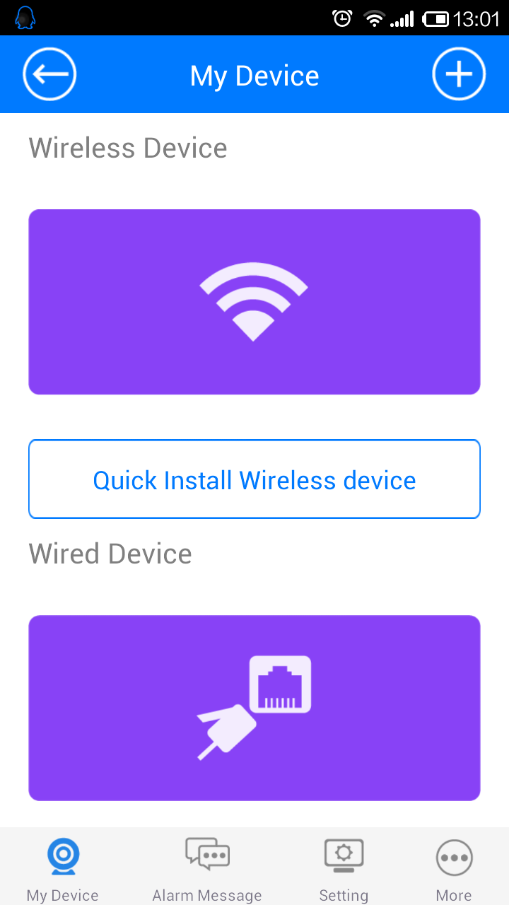
Four step :Configuration and add camera ，step as follows:
A: Configure wired security device
When mobile phones and device connected to the Internet in the same local area network (LAN), through the following steps to view the video, the figure as follows:
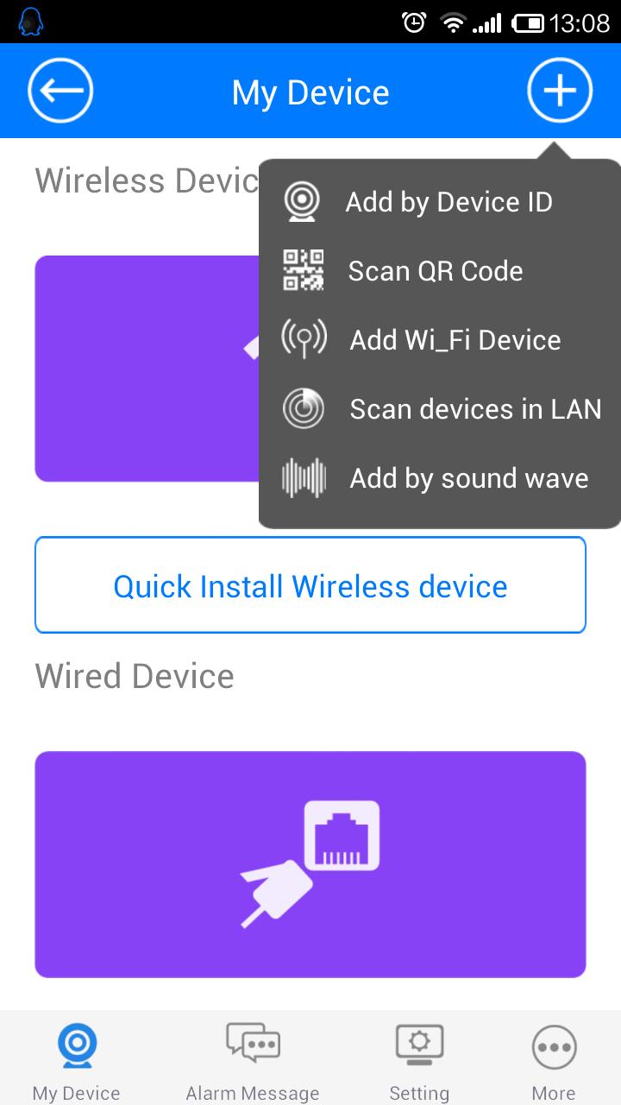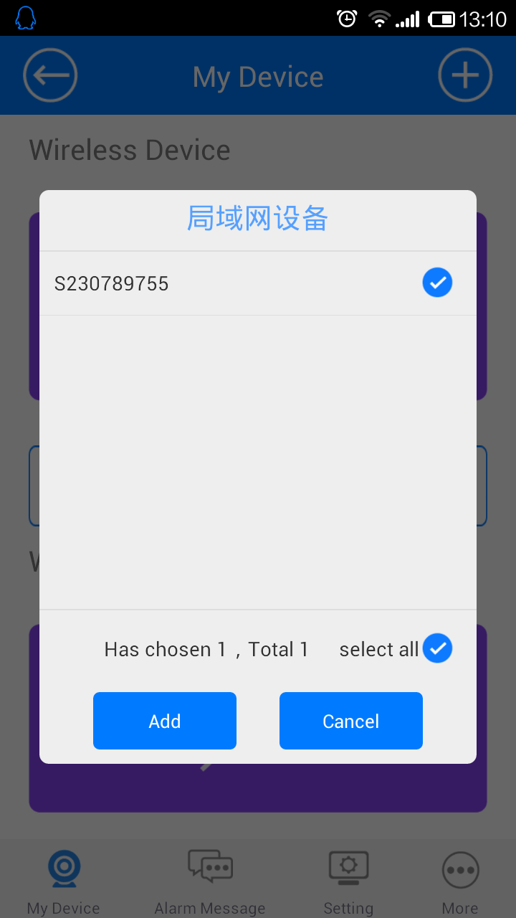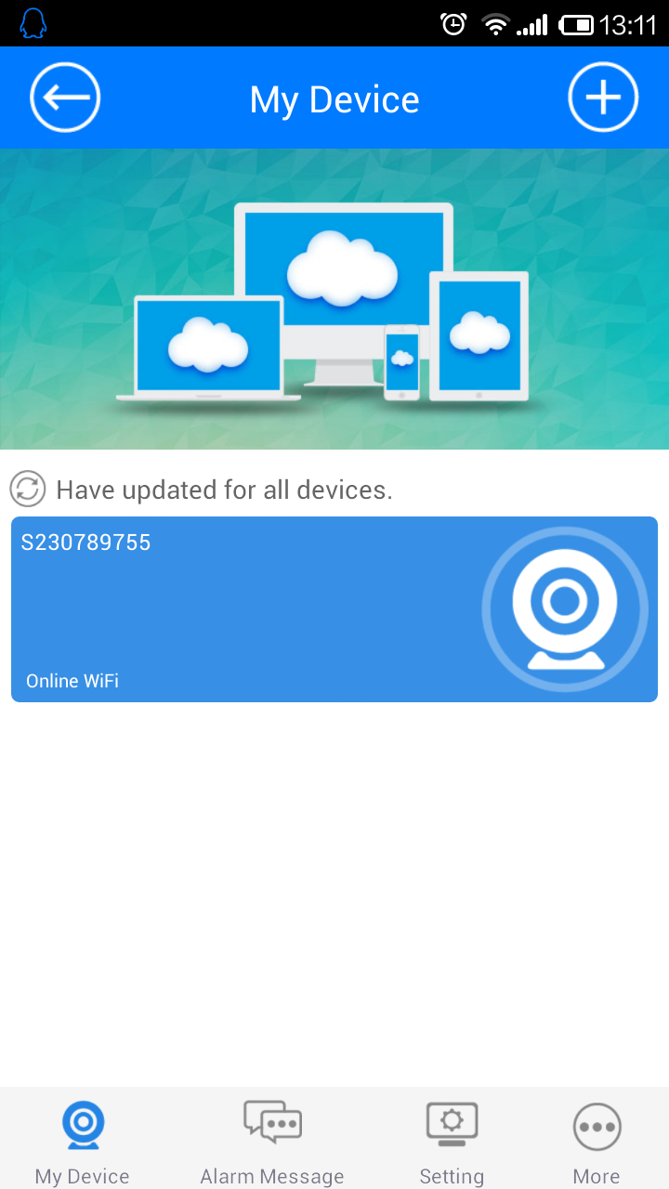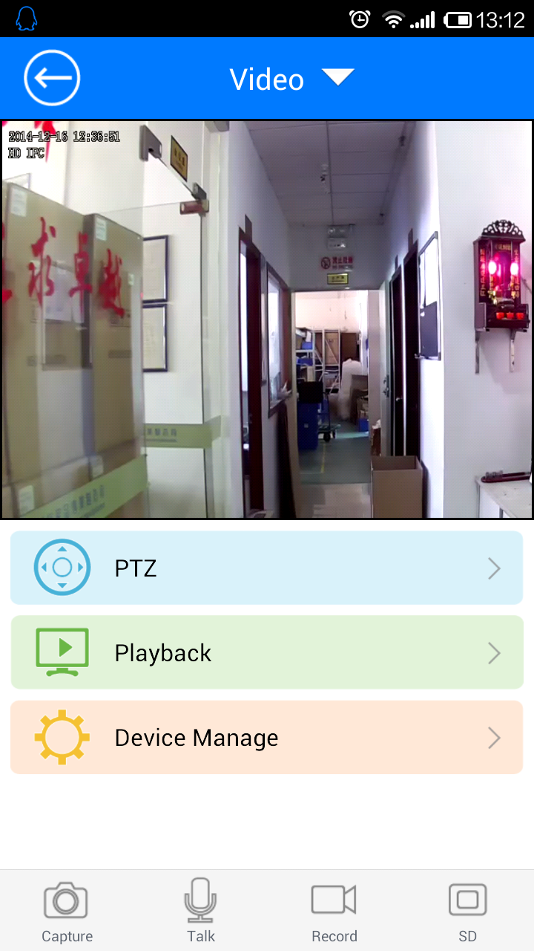
Remarks ：The above steps for android，if you use iOS，No matter wired or wireless devices, can be "acoustic configuration" function, details please refer to the content of the "C.i OS system".

B: Android system config wireless device

Touch “Wireless device”，as follows step to setup。
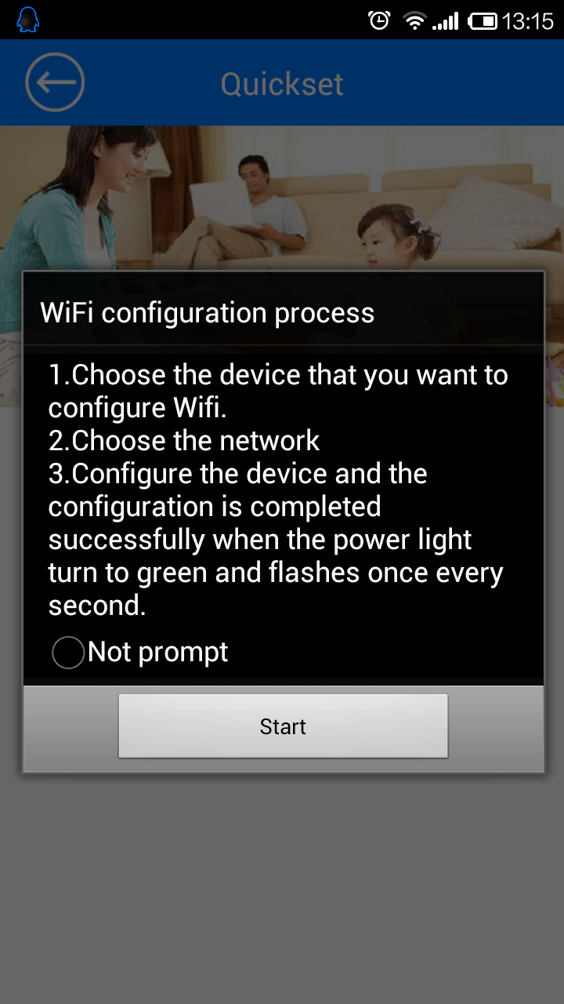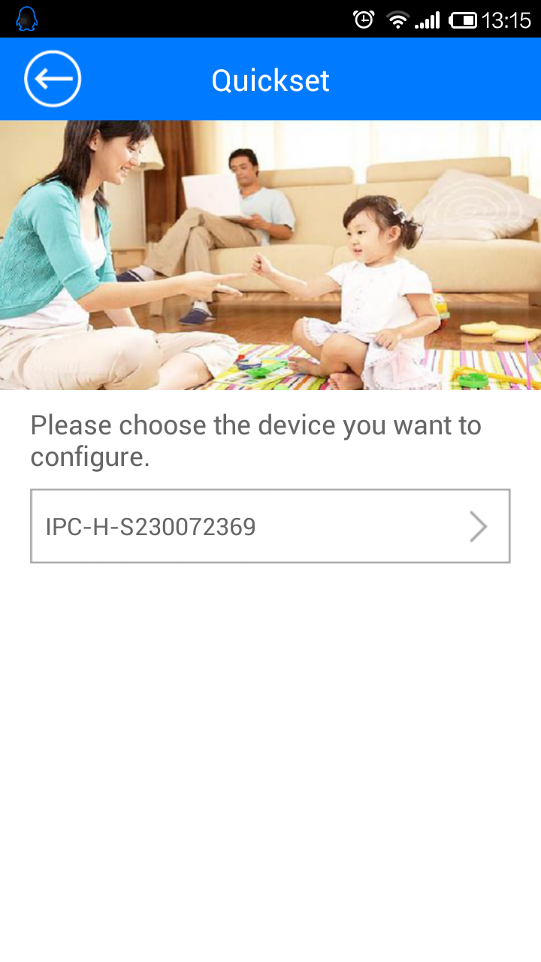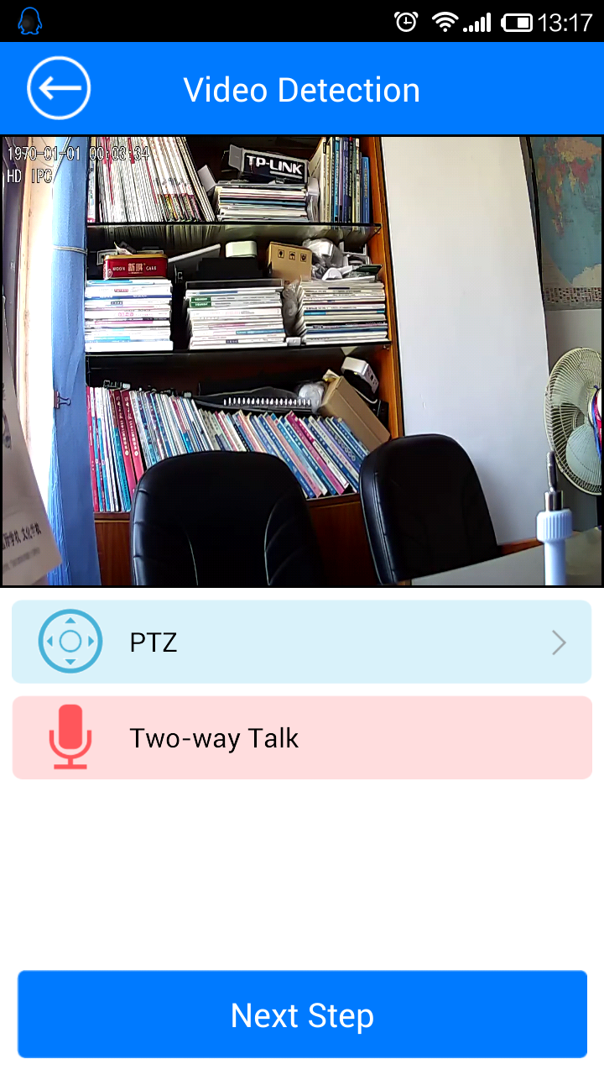

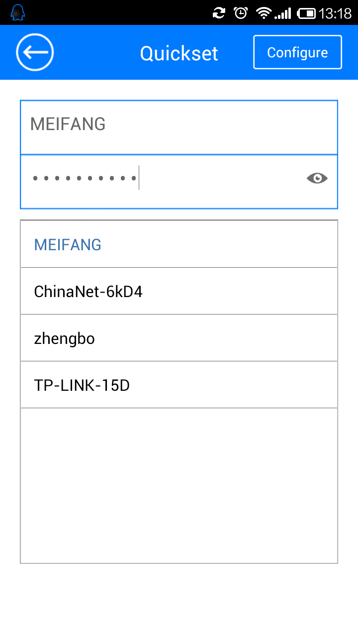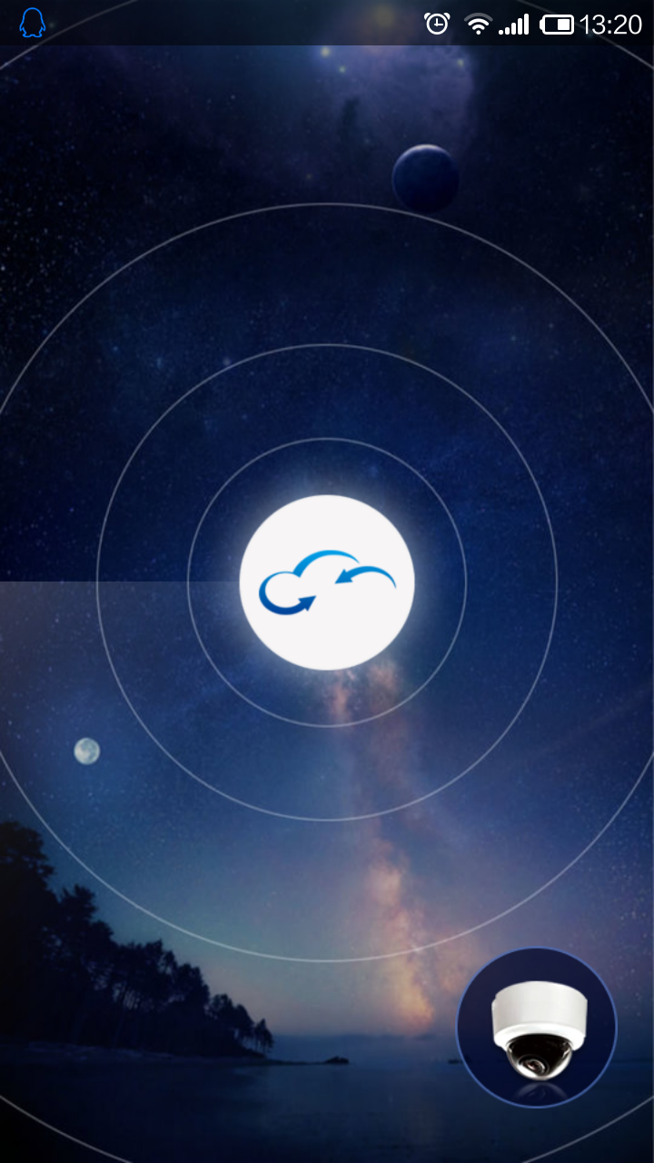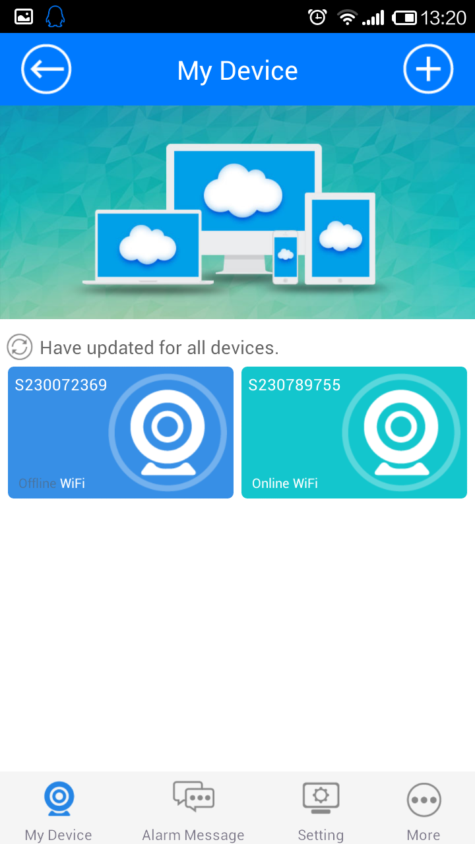
Remarks：
If the device under the condition of the wireless connection need to reconfigure the wireless network, press the device "RESET " for more than 5 seconds (if support audio, will hear "device RESET" hit then setup), when the device is RESET, please follow the above steps to reconfigure.
When the device to connect wire web, part of the device of hot spots will automatically hide, so can't according to the above configuration steps of wireless device , according to A part wire device to . operation

C:iOS
Touch “Wireless device”，as follow step to setup。
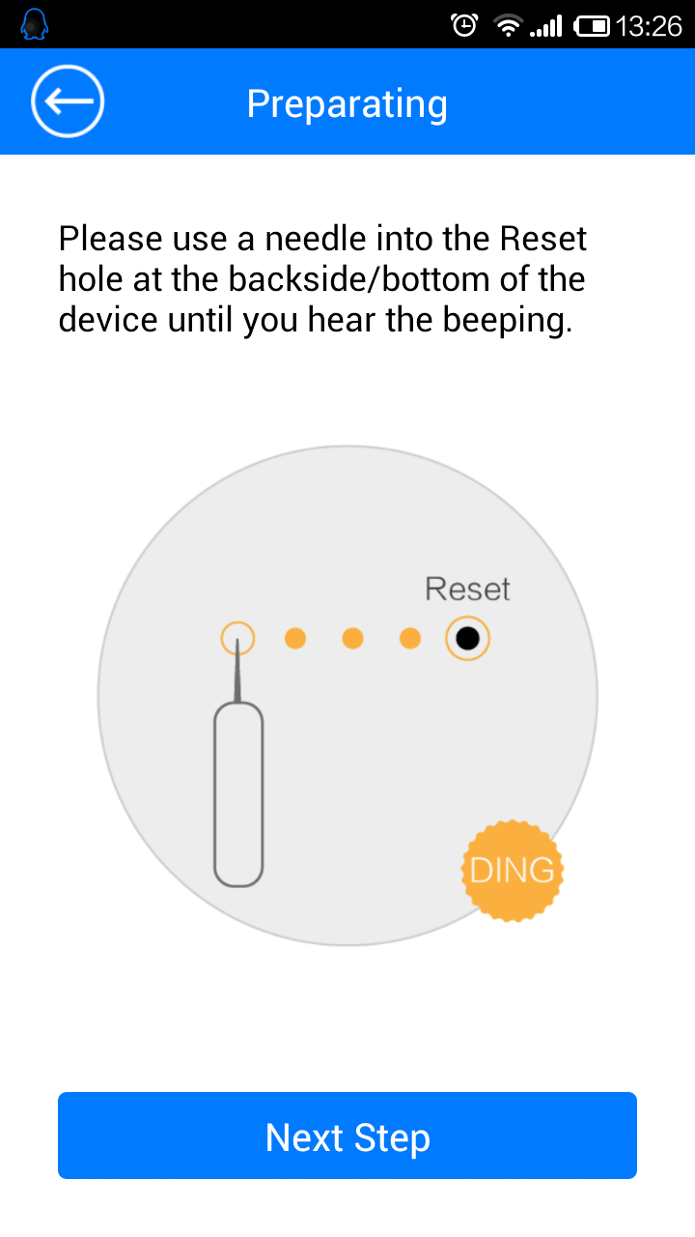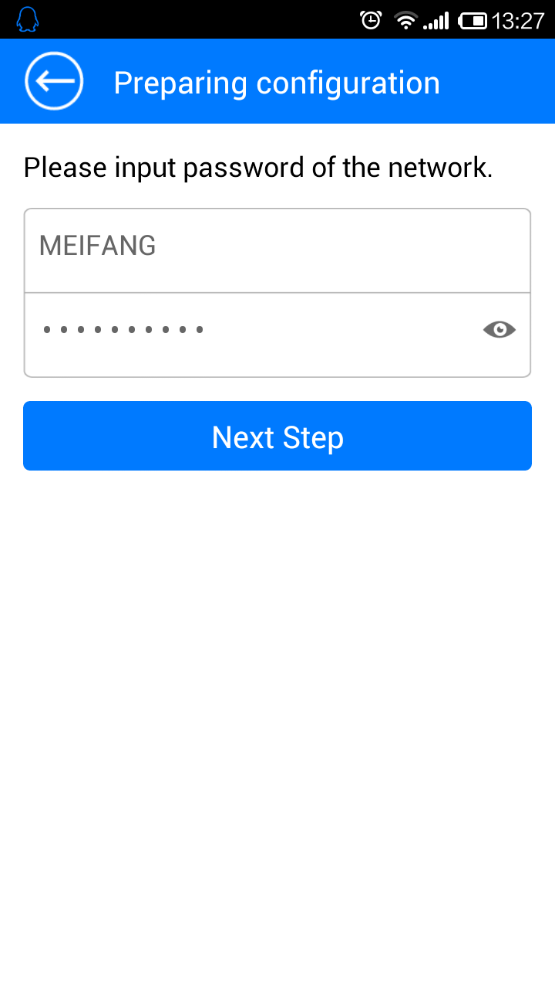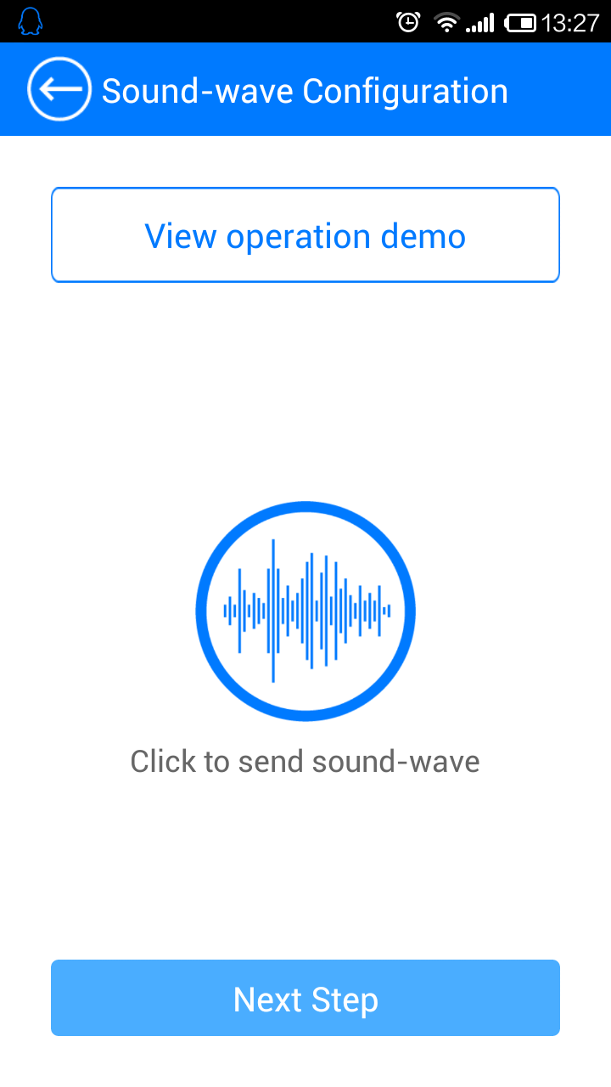

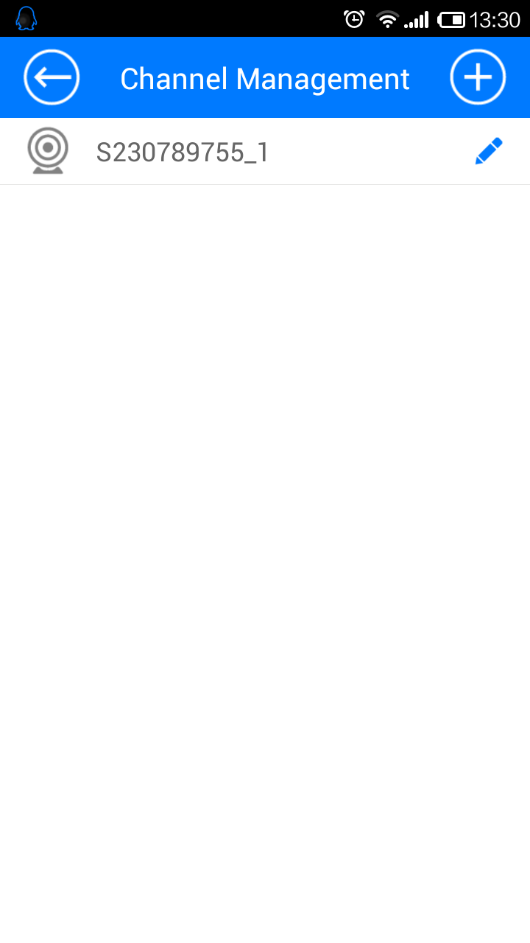
Remark：
If the devices under the condition of the configured success also need to reconfigure, press device “"RESET" button more than 5 seconds, according to the above steps can be configured.

4、Any questions about camera ,Pls contact your distributors to resolve .
user |  | Sex |  | Age
Address
Phone |  |  |  | Zip
Purchase Place
Purchase price |  |  | Sale number
Model |  |  | Device ID
Machine fault
Remark
Repair date |  |  | User signature
Distributor signature |  |  | Distributor phone
Distributor Address
Distributor Idea
Manufacturer idea

